Unity Bootcamp - Creating a 2D Game

Part 2 - Winning and losing

# 

# Spikes

Like real life, we want the player to die if they fall on something sharp. So we’re going to create spikes.

Navigate to *Textures* in the *Project Window* and open up the Sprite Sheet again. Drag in the spikes sprite. In the inspector, rename it to *Spikes* and add a ***Box Collider 2D*** component to it (just like the ground sprite).

However this time we’re going to tick the ***Is Trigger*** tickbox in the ***Box Collider 2D*** component. This means we’ll be able to run code when the player touches it, instead of the player being able to walk on it.

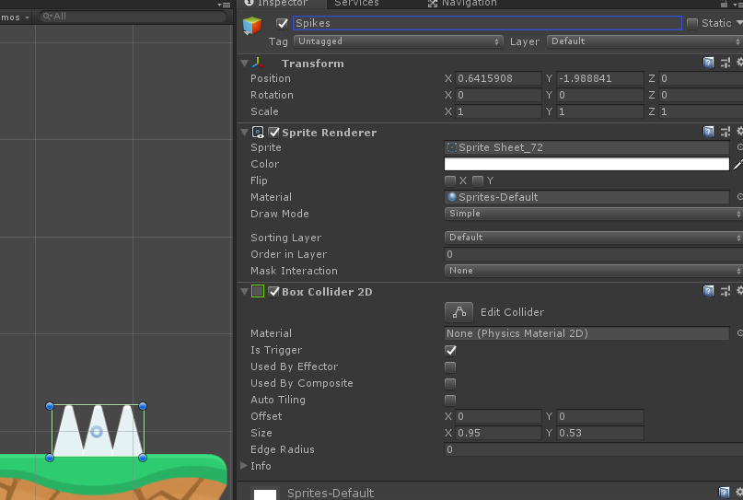

Import the ***DeathZone*** script by dragging it from the file explorer into the Scripts folder in the Project Window. Then drag the script from the *Project Window* onto the *Spikes* gameobject in the *hierarchy*.

The last thing to do is turn the spikes into a ***prefab***, do this by dragging the *Spikes* gameobject from the hierarchy into the *project window*.

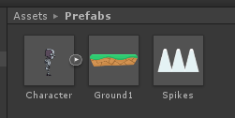

# Play testing

When your character hits the spikes, the level should restart.

# Exit Portal

It’s now time to create an endzone / goal for the player.

Import the***ExitPortal*** script and follow the same steps as the spikes, with the only differences being:

1. Use a different sprite for the exit
2. Name it *Exit Portal*
3. Attach the *Exit Portal* script component to it, rather than *Death Zone*

# Next Level

The *Exit Portal* trigger will try and load the next level in the *Build Settings*. You don’t have another scene yet, so go ahead and create one (*File > New Scene*). Save the scene as *Level2* then add your new scene to the build settings by going to *File > Build Settings* and press *Add Active Scenes.*

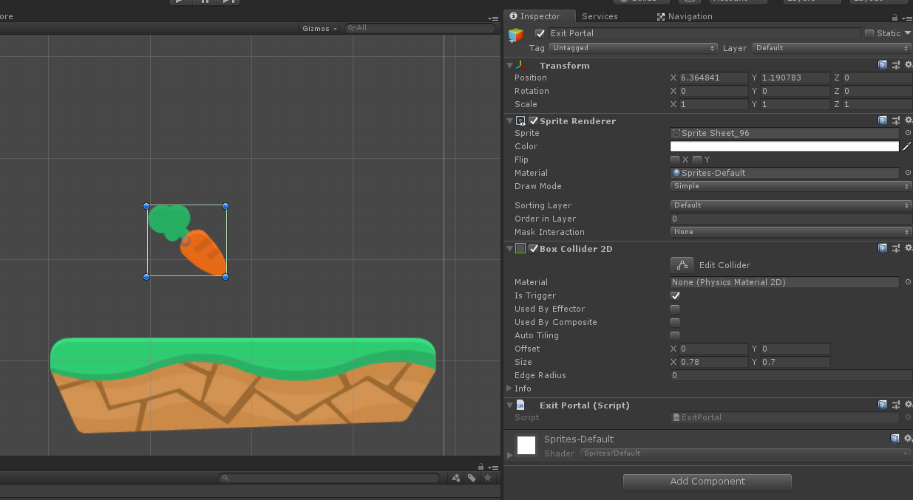

# Play testing

Load back into *Level1* by clicking it in the *Project Window.* Then when you play the game, if you hit the exit portal, it should load you into the second level.

*Optional:* Create a killbox under the map using a huge gameobject with a box collider 2D and the Death Zone script so it will reset the level when the player falls off the side of the map.